Lab 5: Seed Plants
Objectives
- Identify the parts of a flower through dissection
- Learn and “key out” fruit types
- Explore “tree rings” and vascular tissue
- Examine the cones of Coniferophyta
Materials you will need for this lab
- A large flower for dissection – preferably a large lily or similar
- A cone from a conifer tree - ponderosa pine are best

Phylum Anthophyta: the flowering plants
Flower dissection
For this exercise you will need to obtain a flower for dissection. I HIGHLY recommend a LARGE flower from the store, like a big lily. DO NOT use a composite flower lie a sunflower or aster (these are actually many tiny flowers all clustered together).
“Flowers” are actually special leaves modified to facilitate plant reproduction by attracting pollinators!
Flower structures can be divided into two groups: the essential organs and the accessory organs.
- The essential organs are the reproductive structures, which include the stamens (male) and the pistils (female).
- The accessory organs are the sepals and petals, which surround and protect the essential organs.
ESSENTIAL ORGANS
The stamen is the male reproductive organ and is comprised of the anther and the filament.
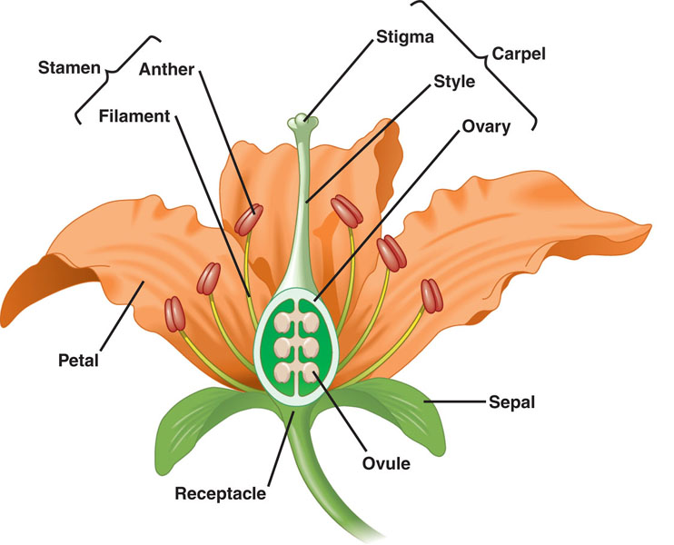
- The anther contains pollen sacs where meiosis occurs forming pollen grains, each containing two sperm nuclei. When the pollen grains mature, the pollen sacs split open to release the dust-like pollen.
- The filament supports the anther.
The Carpel (or pistil) is the female reproductive organ is comprised of the stigma, style, and ovary.
- The stigma becomes moist and sticky when mature to capture pollen grains.
- The style connects the stigma to the ovary.
- The ovary has hollow compartments called locules containing the ovules where cells undergo meiosis to form ova (eggs) containing egg nuclei.
Check out this short video I made of the parts of a flower. http://youtu.be/HaOZ3f_gNlQ
- What do you notice about the sepals and the petals of this flower?

- How many stamens are there? Carpals?
Pollination occurs when pollen grains land on the sticky top surface of the stigma. The pollen grain germinates and a pollen tube emerges releasing special enzymes that digest the cell wall on the surface of the stigma. The pollen tube grows down through the style to the ovary and enters the ovule, making a continuous passageway for the two sperm nuclei to enter the ovum.
Fertilization occurs when the sperm nuclei join the egg nuclei. The fertilized egg becomes an embryo. The wall of the ovule thickens and forms a seed, thus enclosing and protecting the embryo. The ovary wall also thickens and develops into a fruit. In some plants such as apples, the ovary walls become fleshy and contain stored sugars and starches. In other plants such as walnuts, the ovary walls become dry and hard.
Watch this computer animation of flower anatomy and pollination and answer the following questions. Stop at minute 13:45 http://www.youtube.com/watch?v=0UEpq1W9C_E
- There are 4 of what structure inside the anther?
- What are the cells called that comprise this structure & what are their ploidy?
- Which does your flower produce in greater numbers: ovules or pollen grains?
- What type of cell division do these cells undergo?
- What substance does the spore (or pollen grain) become coated in?
- What structures comprise the ovule?
- What is the ploidy of the sporocyte cell within the megasporangia & what type of cell division does it undergo?
- What are the 7 cells comprising the female gametophyte?
- What three cells travel down the pollen tube during fertilization?
- Where does the pollen tube penetrate the megasporangium?
- What happens to the 2 sperms cells inside the megasporangium and what do they become during double fertilization?
- Explain the difference between pollination and fertilization.

Flower dissection
Try to identify all external parts of the flower before you begin the dissection.
Begin by identifying the sepals – the outermost “whorl” of the flower. The sepals may be green and leaf-like or look like the petals – the next whorl.
- How many sepals does your flower have?
Next look at the petals, which are below the sepals (towards the inner part of the flower).
- How many petals are there?
Next GENTLY remove one or two sepals and one or two petals to reveal the inner reproductive parts of the flower.
- Take a photograph of your flower. Upload it into a PowerPoint slide (PPT) and label the remaining sepals and petals. Keep this slide handy – you’re not done labeling!
Now look for the male and female reproductive organs – the Stamens and Carpels as described above.
- How many stamens are there? How many carpels?
- Label the stamens and carpels and all of their components on your slide. NOW you can save the slide as a jpeg image and insert it below.

Fruits and Dispersal
A “fruit” is technically the tissue surrounding the seeds of flowering plants and it may be fleshy or dry. Fruit protects the seeds and helps encourage seed dispersal whether by the little hooks of burrs that catch on animal fur or fleshy sugary fruit that animals will eat and poop out the seeds somewhere far from the parent plant. Some seeds actually can’t germinate unless they have first passed through the gut of an animal!
Fruits are classified into many different groups based on their structure and function.
This part of the lab will require you to “key out” 5 fruits from the key below. Find five fruits in your refrigerator, outside, or during your next trip to the grocery store. Use the dichotomous key to fruits to identify the fruit type and fill in the table. Be sure to include the common name of the fruit, the fruit type from the key, and a probable method of dispersal for each fruit- for example, wind, water, ingestion by birds, mammals, insects, or adhesion to fur, etc. Highlight any fruit or seeds that have structures to enhance dispersal. For example, a dandelion fruit has structures that aid in it floating in the wind.
A Dichotomous key uses a series of binary choices to arrive at a conclusion (identification of fruit type in this case). First select I. Simple fruits (one ovary) or II. Compound fruits. Then work your way hierarchically down through the outline. For example, if I have an apple, I would select I. Simple fruit, then B. Fleshy fruit (not A. Dry fruits), then 2. Ovary with many seeds (it does not have a stone like a cherry), then b. Fleshy fruit develops in part from the surrounding tissue of the flower.

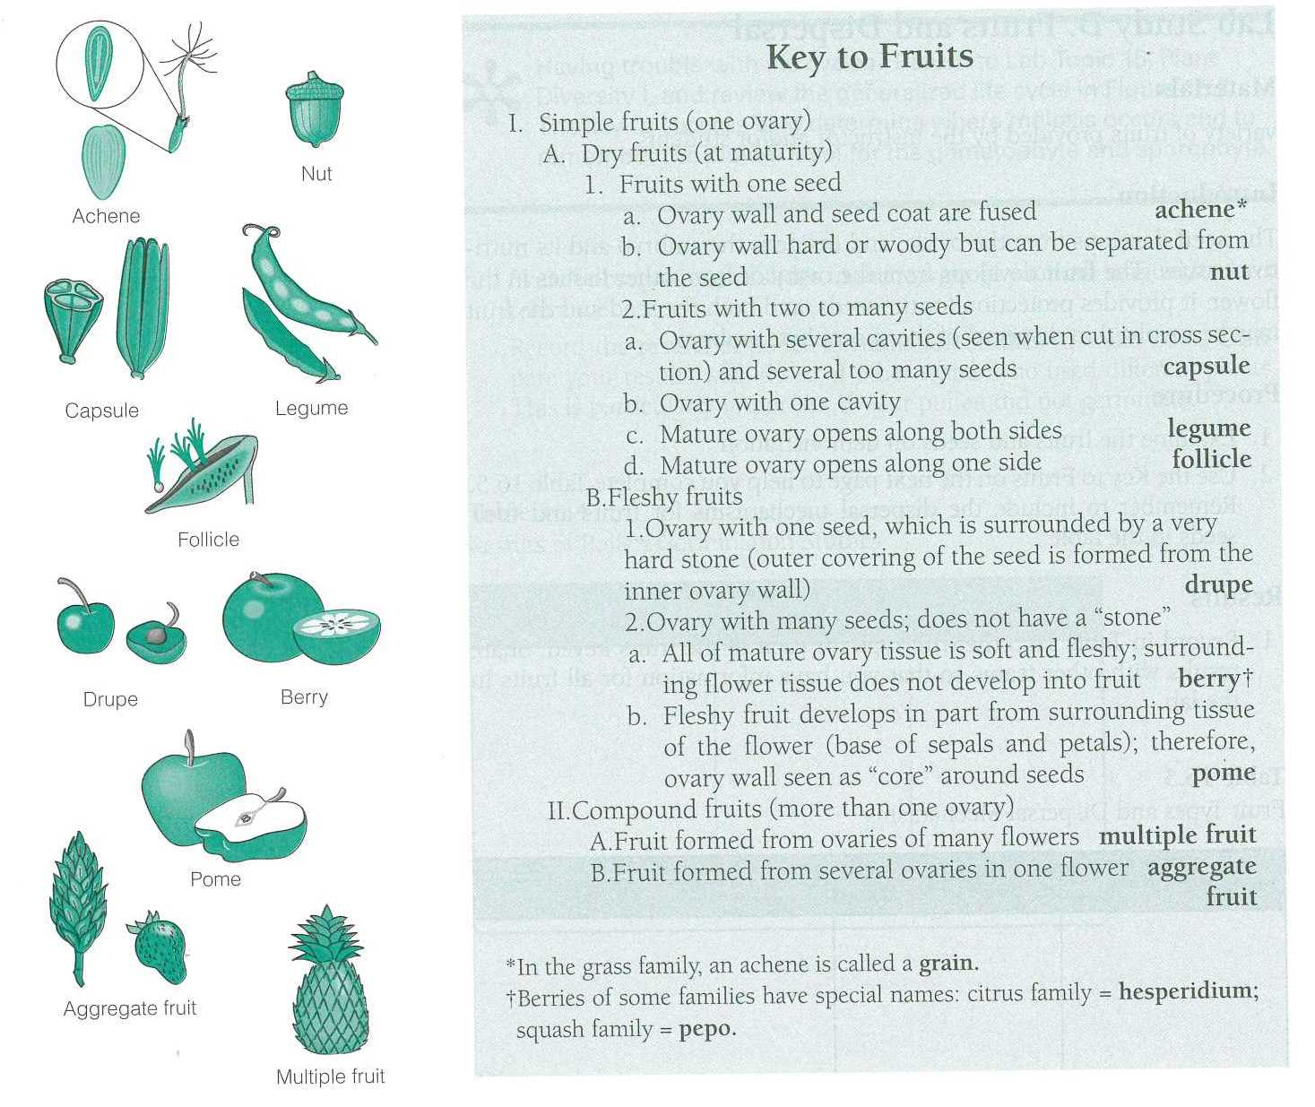
From: Investigating Biology Laboratory Manual, Seventh Edition. Benjamin Cummings.
Fruit table
Plant Name | Fruit type | Dispersal Method
1.

2.

3.
4.
5.

Gymnosperms: Coniferophyta
Gymnosperms form a clade of plants that have “naked” seeds, meaning the seeds are not enclosed in ovaries. Instead they are exposed on modified leaves called sporophylls. In many gymnosperms, these sporophylls are densely clustered together forming cones called strobili. The cone-bearing gymnosperms familiar that are most familiar to us are in the Phylum Coniferophyta which includes pines, firs, junipers, and sequoias.
Like all vascular seed plants, conifers are heterosporous, meaning different types of sporangia produce male and female spores which form separate gametophytes. In conifers, microsporophylls containing microsporangia are clustered together into pollen cones (microstrobili) which produce thousands of tiny microspores or pollen grains which are the male gametophytes.
What we typically think of as a “pine cone” is an ovulate cone comprised of megasporophylls containing megasporangia that produce the female megagametophyte. Each complex megasporophyll of the cone is an ovulate cone scale containing a pair of ovules. Within each ovule, the megasporocyte will undergo meiosis and produce archegonia which in turn form eggs to be fertilized by male pollen within the ovule, where the embryo will develop, eventually resulting in seeds on the surface of the ovulate scale.
To visualize this process, watch this awesome animation and answer the following questions http://www.youtube.com/watch?v=WqGhmkYXcdM
- What is the ploidy of the microsporocyte cells?
- What are the components of a pollen grain?
- What disperses the pollen grains?
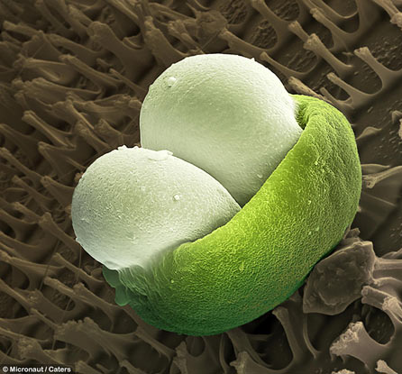
- What structures comprise and ovuliferous scales?
- What is the ploidy of the megasporocyte cell?
- To the right is a SEM of a pollen grain from a conifer with its two inflated “wings”. What would be the adaptive advantage of being these wings? (Hint: think of how pollen is dispersed in conifers).
- In many conifers, the female ovulate cones are all located towards the top of the tree above the male pollen cones. Why would this be? What would be the genetic advantage? (Hint: think pollination and out-crossing vs. self-pollination).
- Why do you think female cones are so tough, often covered in large spikes?

Now, you will need to obtain a “pine cone” or ovulate cone from a pine. Pines are common in Oregon and include many native species, as well as many ornamental species.
Remove one of the larger of the ovuliferous cone scales. Photograph the scale and label the parts that you can recognize from the video. Paste your photograph below.
- What structures are missing from your cone?

Tree rings: primary growth & Secondary growth
One defining characteristic of vascular plants is the presence of vascular tissues which transport water and nutrients throughout the plant, particularly between the roots which obtain water and nutrients from the soil and through mutualistic interactions with mycorrhizal fungi and the leaves where light energy is converted to carbohydrates through photosynthesis.
The vascular system is comprised of xylem and phloem. The xylem is comprised of tough highly lignified cells that are dead at functional maturity and are critical for water transport. In the cross section of roots, stems, and leaves, they appear as large “hollow” cells. Often bundled with the xylem is the phloem, live cells that transport sugars.
Woody plants, such as trees and shrubs, also have secondary growth, whereby they grow thicker via lateral meristems. The lateral meristems are comprised of two layers of dividing cells, vascular cambium and cork cambium. The vascular cambium is a cylindrical layer of meristematic cells that runs the length of roots and shoots and adds secondary xylem from its inner surface and secondary phloem from its outer surface.
The cork cambium produces a thick, tough covering of cells impregnated with wax which protect the stems inner tissues from desiccation, parasites, and pathogens. Together with the secondary phloem it forms the bark, while layers of secondary xylem comprise the “wood”.
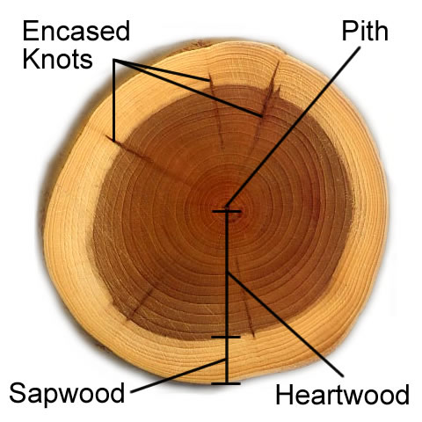
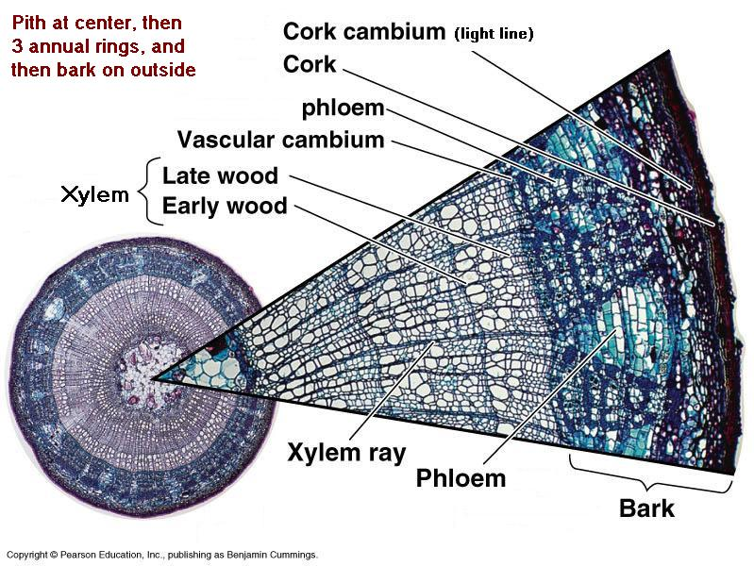
The vascular and cork cambiums continue to add layers to the tree over tens, hundreds, or even thousands of years of their lifetime. During the spring in temperate regions, tree produce heavily lignified secondary xylem cells that are large and thin-walled to conduct more water from the roots up to new leaves. This spring growth results in lighter colored layers of cells called “spring (early) wood”. As water flow slows in the summer, the vascular cambium forms layers of secondary xylem with smaller and thicker cell walls which appear darker. These layers are called “summer (late) wood”. In the winter the tree stops growing. Therefore, each year the tree puts on one new layer of light spring wood and dark summer wood. This seasonal pattern of growth creates the “tree rings” you see in a cut tree.
The cork cambium also continues to produce new layers of cork, the outer most sloughs off over time. As trees age, the old inner layers of secondary xylem stop transporting sap and are called heartwood, while the outer functioning layers are called sapwood.
Watch these videos on using tree rings in research
https://www.youtube.com/watch?v=xmZO7aRgcW4
https://www.youtube.com/watch?v=FAOYkx8E-Gc
- What is dendrochronology?
- How can we detect drought by looking at tree rings?
- Why do you think trees in the tropics don’t show tree rings?
- What might have happened to the Roanoke colony in the 16th century in North Carolina?
Slices from the trunk of a tree are sometimes called “tree cookies” and they reveal the rings. Imagine thin slices the thickness of a music record. What would the music of tree rings sound like? Bartholomaus Traubeck wondered that very thing. So he created a record player that translates the different colors and textures of tree rings into music! Rather than use a needle like a record, sensors gather information about the wood and turn them into piano notes. Check out the music here http://traubeck.com/years/
- What do you think?

